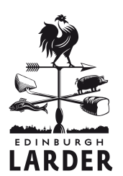

winter menu

** set menu options available
lunch (12-2.30) 2/3 courses £12/£15
pre theatre (5.30-6.30) 2/3 courses £15/£18

seasonal aperitifs
larder tatanka cocktail 5.00
lavender gin lemonade cocktail 5.00
gin fizz 6.00

starters
roasted beetroot salad baby leeks, fern abbey ewe’s brie 5.50**
smoked mackerel and horseradish pate, oatcakes 5.50**
chicken breast and whitebait salad, rye crisps 5.50**
cream of celeriac soup with Scottish truffle shavings & homemade bread 5.95
queen scallops with Jerusalem artichoke and sweet woodruff vinaigrette 6.50
pheasant terrine with pickled wild mushrooms and redcurrants 6.50
mains
sides
bread of the day with herb butter 2.00
seasonal vegetables 2.50
seasonal mixed leaves 2.95
beef dripping chips with Hebridean sea salt 3.50
(can be veggie on request)
winter squash and barley risotto, toasted walnuts, wild mushrooms 12.95**
pan fried mullet, wilted spinach, fennel, scurvy grass pesto16.95**
slow roasted leg of pork, quince, crow garlic mash, broccoli 16.95**
breast of goose with roast potatoes, carrots, sprouts and cranberries 18.95
onion marmalade tart with salt baked root vegetables, pickled elderberries and seasonal leaves 13.95
baked coley with cockle broth, crispy leek, kale and chestnuts 17.95

special thanks to some of our suppliers who made this particular menu possible: Fungi & Forage, Welch Fishmongers, Peelham Farm, Phantassie, Cyrenians, Creelers, Errington Cheese Company
desserts

selection of homemade ice creams and sorbets with Mara seaweed shortbread 5.50**
try with - Moscato Passito, Palazzina, Italy

meadowsweet rice pudding, blackberry jam, honey biscuits 5.95**
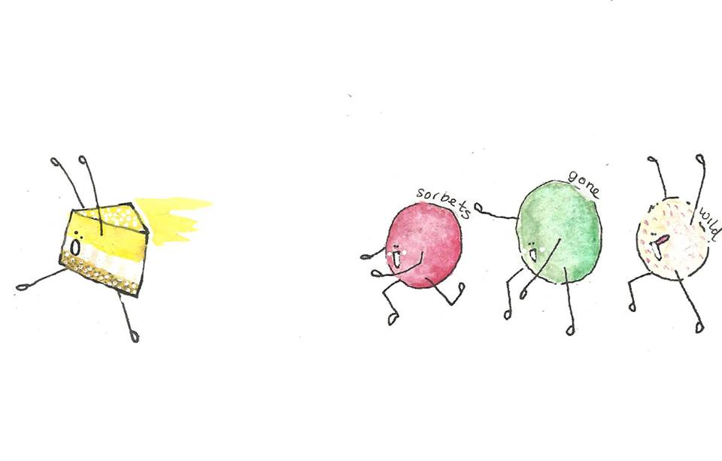
try with - The Hive 12yr, Wemyss Malts

spiced chocolate slice, salted caramel, crème fraiche 5.95**
try with – Tamhdu 10 yr, matured in sherry cask

cobnut treacle tart, poached pear and cinnamon ice cream 6.95
try with – BenRiach 12yr Old Dark Rum Finish

mulled blackberry and sweet woodruff trifle 6.25
try with – Coteaux du Layon, Carte D’Or, France

Scottish cheeses with homemade oatcakes and fresh chutney 7.50
sweet wine pairing – Glotonia Pedro Ximenez Los Pecadillos, Andalusia

larder whisky selection

The Hive 12yr, Wemyss Malts, Malt Blend,40% £4.8
nose: Honeyed and malty, cooked apples, beeswax and a tinge of soft smoke.
palate: Creamy and supple, a lot of honey, dried apricot, manuka honey, granary toast, melted butter, toffee and sweet cinnamon.
finish: Beeswax and honey on hot buttered toast. Allspice and nutmeg on the tail.

BenRiach 12yr Old Dark Rum Finish Arumaticus Fumosus
Speyside, 46%
£5.00
nose: Slabs of peat! Sweet cereals waft in and out.
palate: Rich and peaty, more supple than the nose suggests. Sweet barley, lots of smoke, the interplay between rum and the darkness of BenRiach is quite spectacular.
finish: Bittersweet syrupy Muscovado.
apricots, rosehips and chocolate, with an avalanche of rum and sultanas in the finish.

Compass Box ‘Great King Street’, Artisan Blend, 43% £4.50
nose: Tropical fruits – banana, coconut, candied pineapple, lemon bonbons, slightly biscuit.
palate: Caramel, vanilla fudge, toffee, faint ginger, wood chips.

Tamhdu 10 yr, matured in sherry cask, Speyside, 40% £4.60
nose: Crunchie bars, eccles cakes, a touch of rubber, black liquorice, brown sugar, vanilla cream, victoria sponge, berries and foresty hints – rich earth and damp green leaves.
palate: An oily mouthfeel with caramel, pepper and stewed oranges up front, and sherbert and milk chocolate coming in behind.
finish: Medium length, with sweet wood turning slowly dry and spicy, with a burst of spiced butter fading to lightly bitter barrel char.

