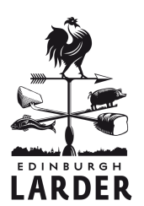

autumn menu

** set menu options available
lunch (12-2.30) 2/3 courses £12/£15
pre theatre (5.30-6.30) 2/3 courses £15/£18

seasonal aperitifs
bramble vodka cocktail 5.00
lavender gin lemonade cocktail 5.00
Barney’s capital porter beer 4.25
starters
today’s seasonal soup with homemade bread 4.95**
roasted beetroot salad baby leeks, fern abbey ewe’s brie 5.50**
crispy squid, sweet cicely mayo 5.50**
tea boiled duck egg, smoked ham, herb emulsion, wood sorrel 6.25
soused mackerel with toasted rye bread and crème fraiche 5.95
pressed rabbit with summer slaw and blackberries 6.75
sides
bread of the day with herb butter 2.00
seasonal vegetables 2.50
seasonal mixed leaves 2.95
beef dripping chips with Hebridean sea salt 3.50
(can be veggie on request)
mains
roasted rainbow carrots, squash and celeriac, wild mushrooms, spelt and cobnuts 12.95**
pan-fried sea trout, wilted sea vegetables, cauliflower and runner beans 16.95**
pork belly, heritage potatoes, tomatoes, courgette, summer greens 16.95**
baked hake, cockles, seasonal beans, chilli, tarragon 18.95
Jerusalem artichoke and almond tart with a warm potato and shallot salad 13.95
breast of young grouse, lentils, parsnip, green beans and pontack sauce 17.95

desserts

selection of homemade ice creams and sorbets with Mara seaweed shortbread 5.50**
sweet wine pairing– Moscato Passito, Palazzina, Italy

Scottish plum and apple crumble with sweet cicely ice cream 5.95**
whisky pairing - Compass Box ‘Great King Street’

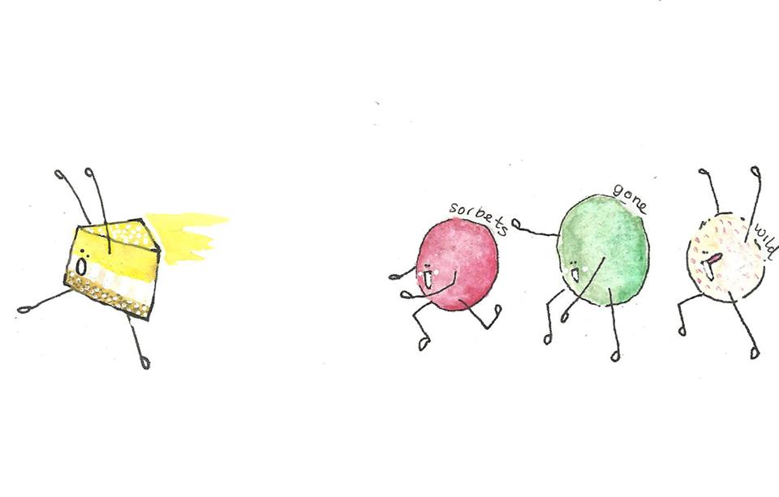
homemade sweet cicely brownie, crème fraiche 5.95**
whisky pairing – Bowmore 12 yr

bramble frangipane tart with sweet woodruff ice cream 6.95
whisky pairing – Balvenie Double Wood

chilled meadowsweet rice pudding with poached pear and sea buckthorn soup 6.25
sweet wine pairing – Coteaux du Layon, Carte D’Or, France

Scottish cheeses with homemade oatcakes and fresh chutney 7.50
sweet wine pairing – Glotonia Pedro Ximenez Los Pecadillos, Andalusia

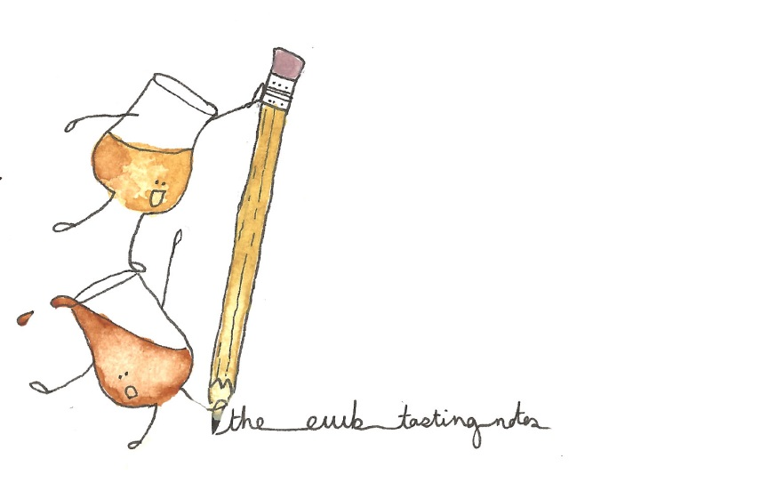
Balvenie 12 yr old double wood, 40% 6
nose: Gristy, supple nuttiness, grapey
palate: bourbon, vanilla, delicate peat

Compass Box ‘Great King Street’, Blend, 43% 4.50
nose: tropical fruits – banana, coconut, candied pineapple, lemon bonbons, slightly biscuit-y
palate: caramel, vanilla fudge, toffee, faint ginger, wood chips

Bowmore 12 yr old single malt 40% 5.50
nose: subtle lemon and honey balanced beautifully by Bowmore’s trademark peaty smokiness
palate: sweet and delicious, heather honey and gentle peat smoke

special thanks to some of our suppliers who made this particular menu possible: Fungi & Forage, Welch Fishmongers, Peelham Farm, Phantassie, Cyrenians, Creelers, Errington Cheese Company

